**Project Report**

**1.INTRODUCTION**

**1.1 overview**

A "barbecue party restaurant" typically refers to a dining establishment that specializes in hosting barbecue parties or events for groups of customers. These restaurants are designed to provide a fun, communal, and celebratory atmosphere where people can gather to enjoy a barbecue feast. Here's an overview of what you might expect from a barbecue party restaurant:

Party Atmosphere:

A barbecue party restaurant aims to create a lively and festive atmosphere that's perfect for groups celebrating special occasions or simply enjoying a fun night out.

Family and Group-Friendly:

These restaurants are ideal for families, large groups, and celebrations. They may have private dining areas or party rooms to accommodate events like birthdays, reunions, and corporate gatherings.

Variety and Customization:

Barbecue party restaurants often aim to offer a wide variety of meats, side dishes, and flavors to cater to diverse tastes and preferences.

Interactive Dining:

- Some establishments encourage guests to participate in the cooking process through outdoor grilling stations, allowing for an interactive and engaging dining experience.

Overall, a barbecue party restaurant offers a vibrant and entertaining setting where guests can indulge in a feast of smoked and grilled meats, enjoy the company of friends and family, and immerse themselves in the lively atmosphere of a barbecue celebration. These restaurants are known for bringing people together to savor the flavors and traditions of barbecue cuisine in a festive and memorable way.

**1.2 Purpose**

I create my own traditional dish and then sale the dish for affordable price.

**2.Problem Definition & Design Thinking**

**2.1 Empathy map**



**2.2 Ideation & brainstorming map**



**Result :**



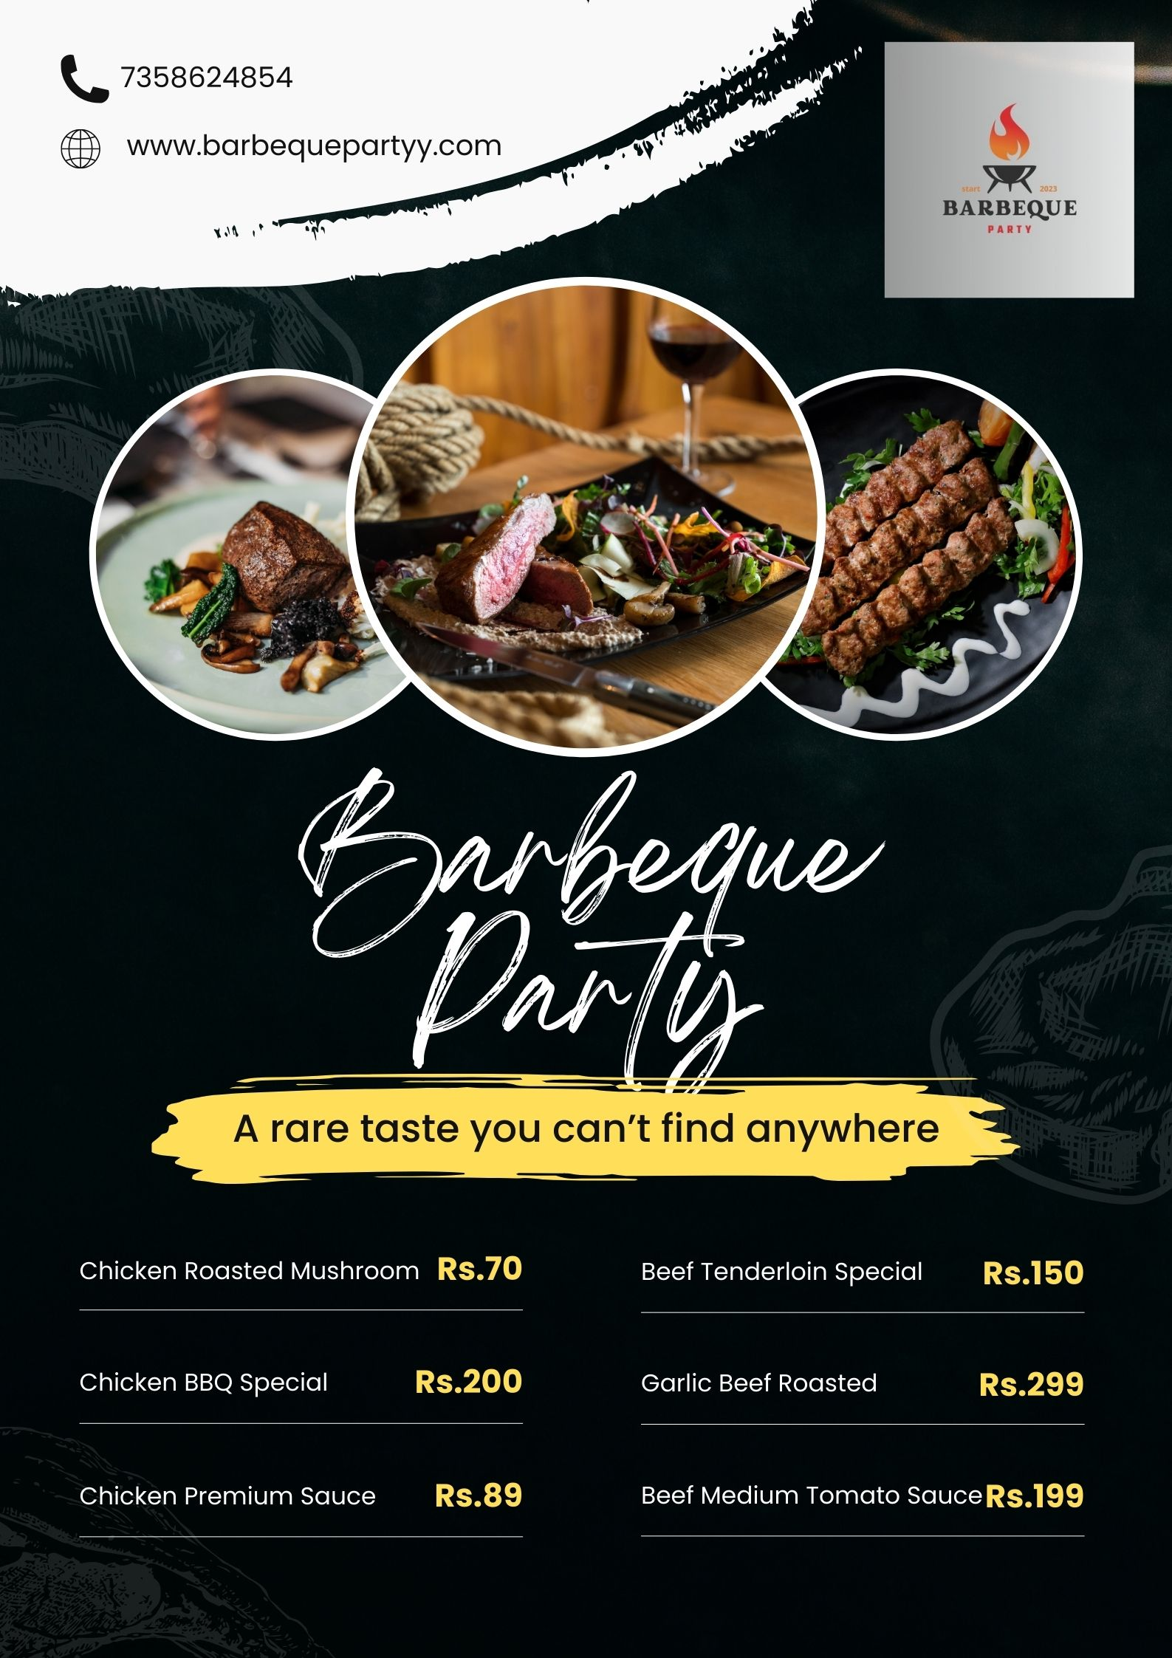

**4.Advantages & Disadvantages**

**Advantage:**

1**. Unique Flavor and Experience**

2. **Variety of Meats and Flavors**

3.Affordable Price

**Disadvantage:**

1. **Waste Management**

**2.Competition**

**5.Applications**

1.Markets

2.Bussiness Retail

3.Industry

**6.Conclusion**

In conclusion, barbecue restaurants are a beloved and integral part of the culinary landscape, offering a unique and flavorful dining experience that celebrates the art of barbecue cooking. These establishments serve as cultural touchstones, bringing communities together over shared meals and the savory, smoky flavors of barbecue.